LAB PROGRAM 1: QUADRATIC EQUATIONS(13/10/25)
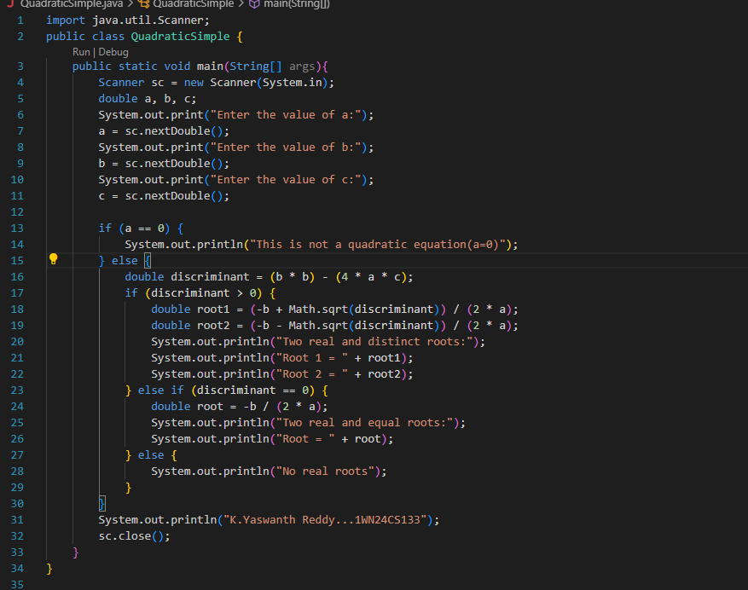
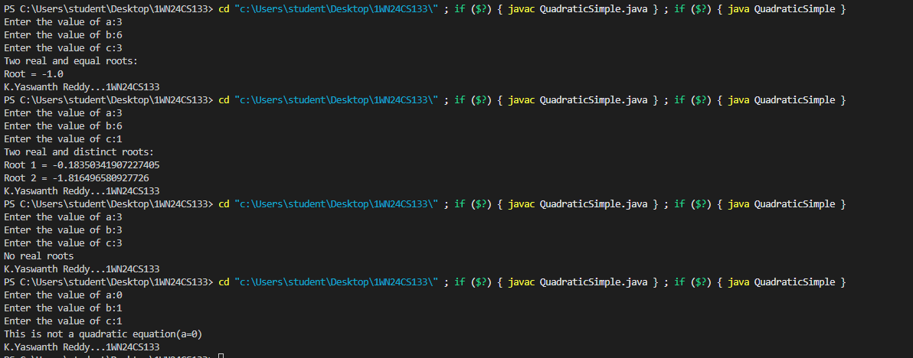

03/11/25
LAB PROGRAM 2
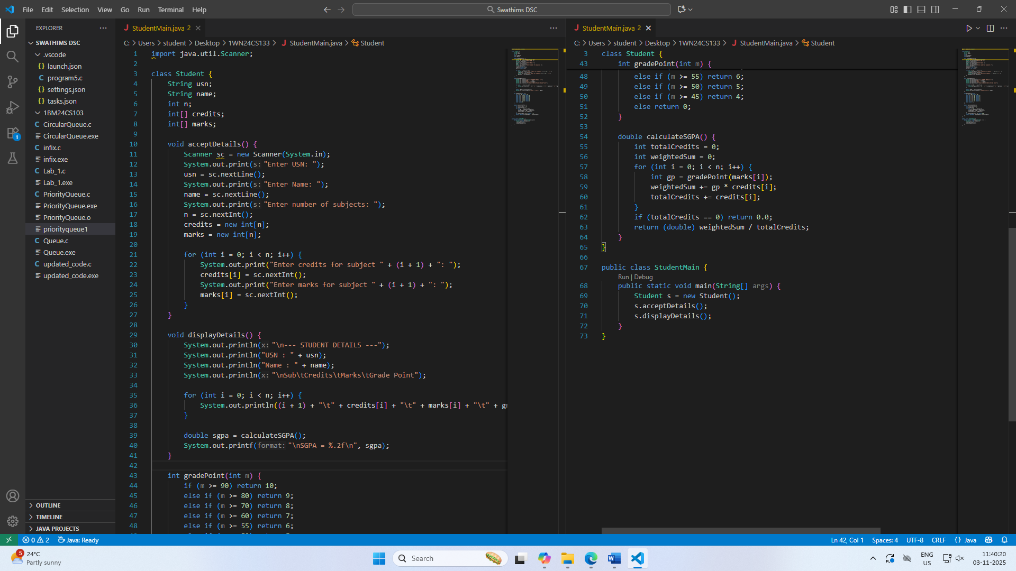
OUTPUT:
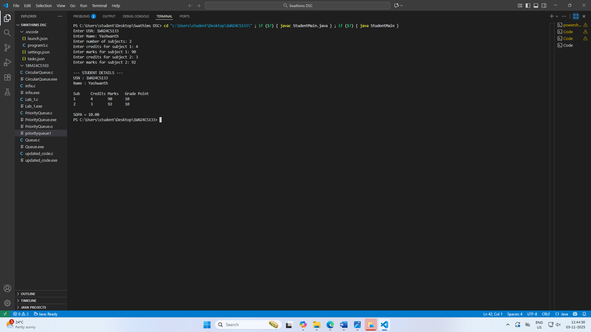

3.
CODE:
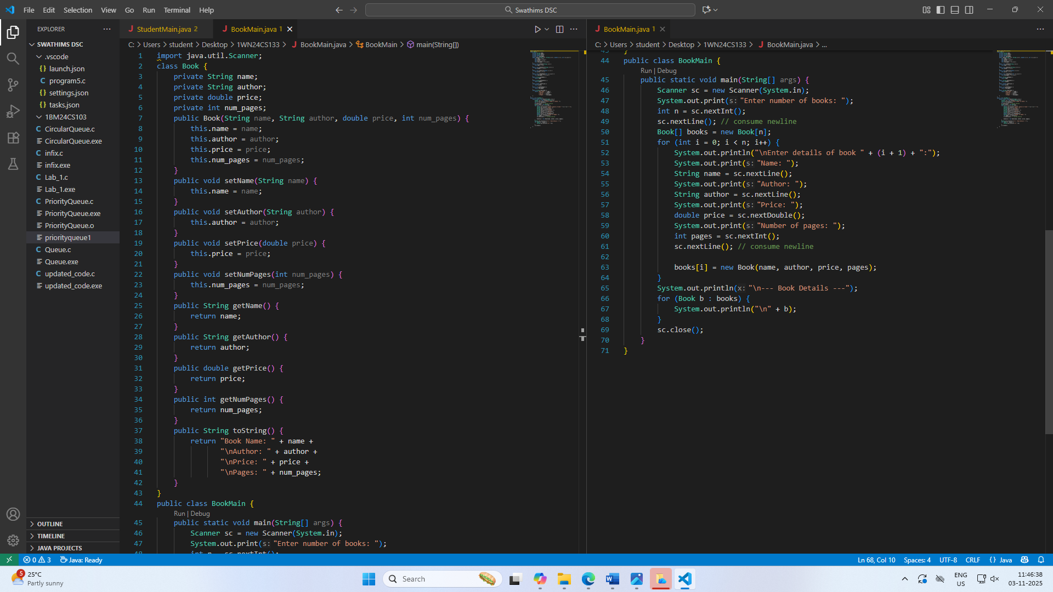
OUTPUT:

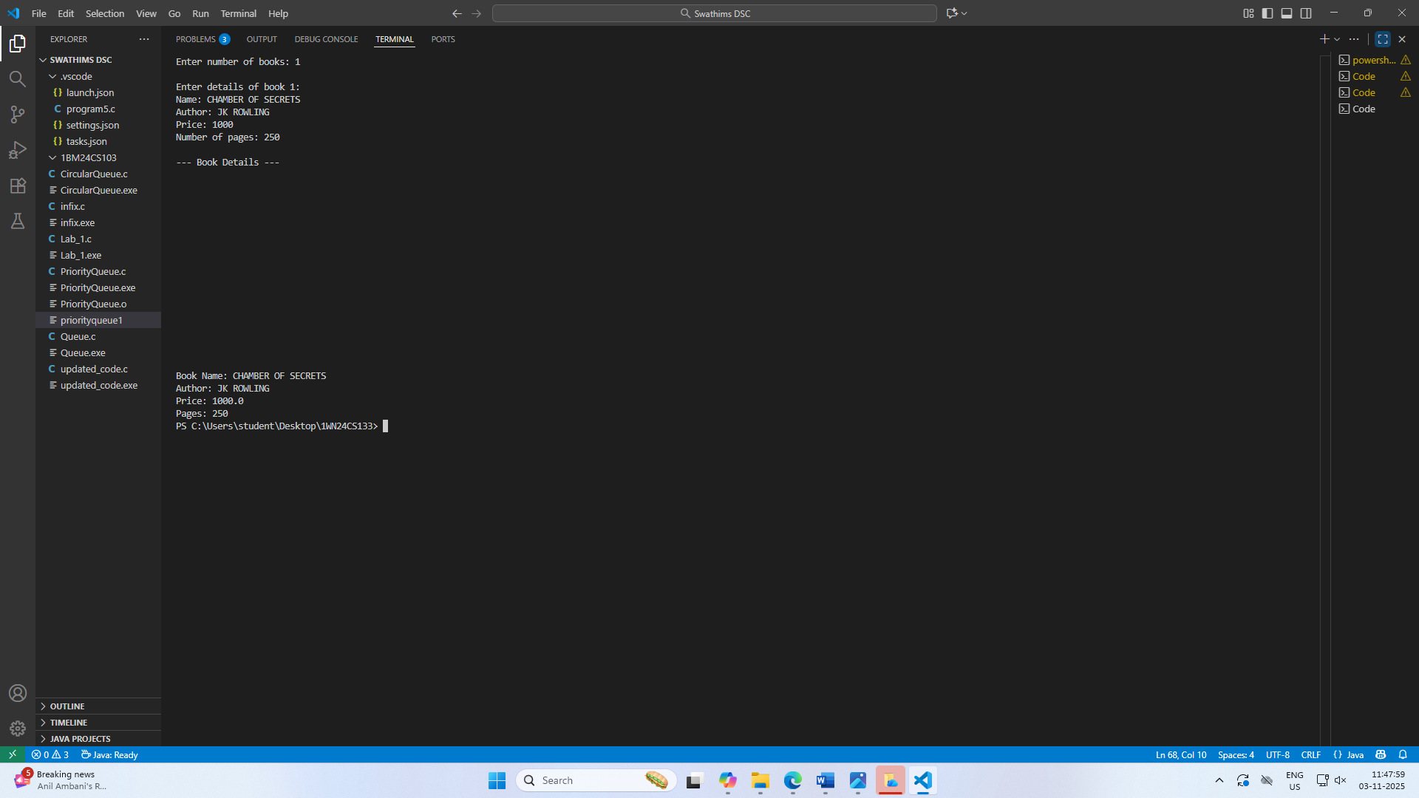

LAB PROGRAM 4
CODE:

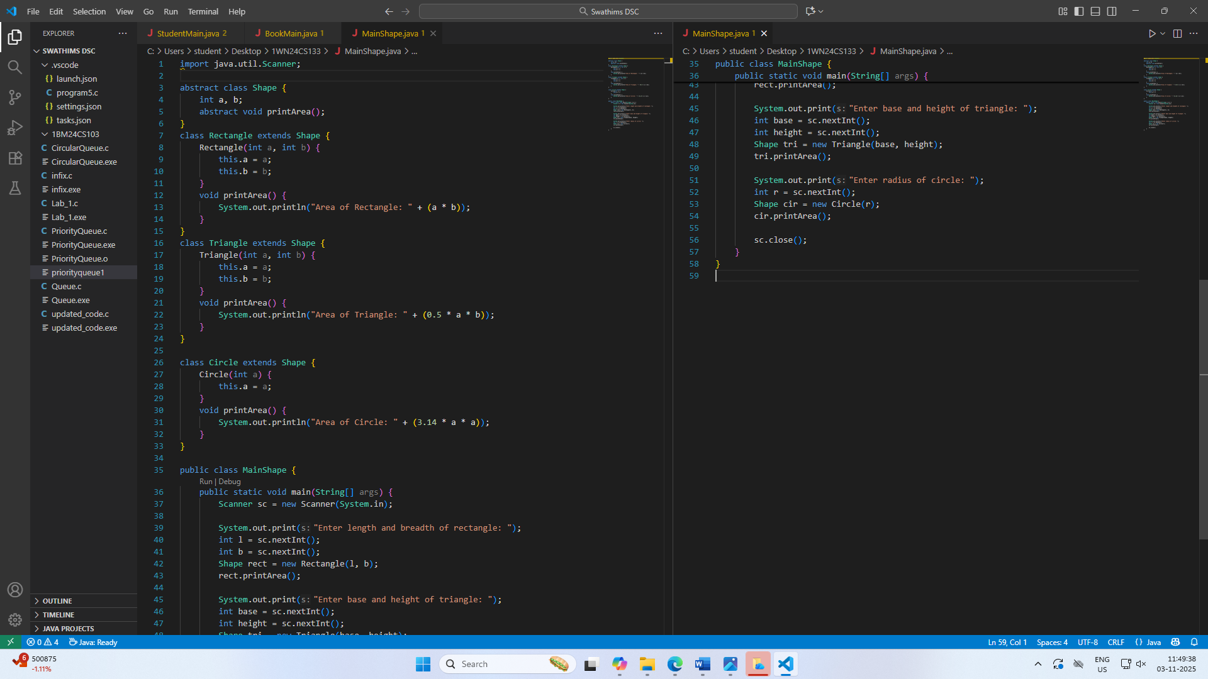
OUTPUT:
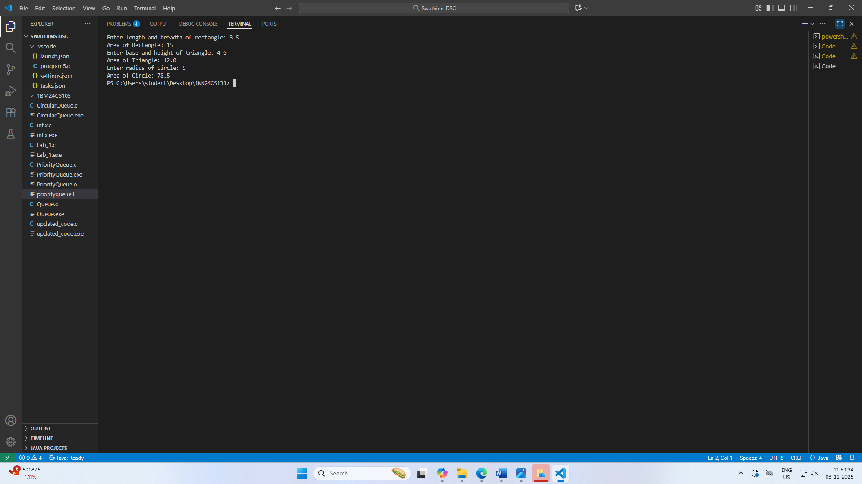
10/11/2025
Lab program 5 code:
OUT

OUTPUT:
24/11/2025: lab program 6
Code:
OUTPUT:

